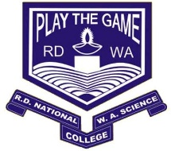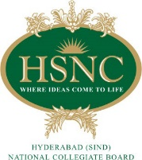

**R.D. & S.H. NATIONAL COLLEGE**

**& S. W.A. SCIENCE COLLEGE,**

**Bandra, Mumbai – 400050.**

**Department of Computer Science**

**PROJECT CERTIFICATE**

This is to certify that **Mr. Ganesh Umesh Tiwari** of **T.Y.B.Sc. (Sem V)** class has satisfactorily completed the Project entitled **Quiz App**, to be submitted in the partial fulfillment for the award of **Bachelor of Science** in **Computer Science (Semester V)** during the academic year **2018 – 2019**.

It is further certified that the project is an original work and it has not formed the basis for the award of any degree, associateship, fellowship or any other similar titles.

**Date of Submission:**

**Internal Project Guide Co-Ordinator,**

**Department of Computer Science**

**Signature of External Examiner**